Response to Comments for Manuscript ID BIB-25-0873 “MVRBind: Multi-view Learning for RNA-Small Molecule Binding Site Prediction”

We really appreciate the Associate Editor for handling and coordinating this peer review and the valuable comments from the anonymous reviewers. Based on the suggestions and comments, we have carefully revised the paper and provided point-to-point responses in this letter. The questions and com- ments from reviewers are marked with blue color. Meanwhile, we also highlight the changes in the revised manuscript in red.

The main changes in the revised manuscript are summarized as follows:
- Methodological Novelty and Design: We highlighted the novelty of MVRBind’s architecture in jointly modeling multiple structural views and spatial scales, as well as their interactions, as suggested by Reviewer #2.
- More Baselines for Experimental Evaluation: We added new experiments comparing MVRBind with RNABind (using equivariant neural networks) and three fine-tuned RNA foundation models, showing superior performance in RNA small molecule binding site prediction. These experiments were added to address the comments from Reviewer #2.
- New Dataset for Experimental Evaluation: We introduced the HARIBOSS dataset as a broader benchmark to evaluate various methods. These experiments were added to address the comments from Reviewer #2.
- Enhanced Literature Coverage: We improved the Introduction section by referencing tools like fPocketR and recent deep learning studies including various RNA foundation models, as suggested by both Reviewers #1 and #2.
- Improved Code Usability and Documentation: We fixed installation issues, added OS-specific setup scripts, and clarified README instructions and examples, addressing Reviewer #1 feedback.
- Other Revisions: We refined terminology, improved figure readability, moved key details to the main text, clarified metrics, and added computational efficiency metrics, based on all reviewers’ suggestions. We also updated the Discussion section to discuss the limitation of our methods and possible future work, in response to feedback from all reviewers.
The detailed point-to-point responses to the reviewers’ comments are presented on the following pages.

Reviewer #1

Summary: Chen et al. describe MVRBind, a new method for predicting RNA-small molecule binding sites. The topic of binding sites discovery is very important. Authors provide an in-depth description of the method’s technical details and present the benchmarking results for multiple test sets. Interestingly, the model can accurately predict binding sites for fully in silico-predicted RNA structures (such as those from RNA Composer). The article is well written. The method is presented and tested in detail.
Response: Thanks very much for your time and efforts to review this manuscript, and we really appreciate your valuable suggestions. We have carefully addressed all the comments and suggestions when preparing the revision of this manuscript.

Comment 1: Code repository
- I was not able to create the conda environment. The issue is ”ResolvePackageNotFound” for 67 packages.
- I suggest removing prefix: D:\code\tool\anaconda\envs\MVRBind from the environ-
ment.yml file.
- As the end user, I miss the example(s) of how to run the software, with exact commands, working example(s), and sample output provided in the README.

Response 1:
- We sincerely apologize for the inconvenience caused. The issue might be due to differences in operating systems. To facilitate environment setup, we have provided batch scripts for Windows and shell scripts for Linux to help the users create the environment with a single command. Please refer to the README file for detailed instructions.
- Thank you for pointing this out. We apologize for the oversight. The prefix field was mistakenly left in the environment.yml file. It has now been removed to ensure a smoother setup process.
- We apologize for the lack of clarity in the original README file. We have now updated it to include step-by-step instructions on how to run the code, including example commands, a working use case, and sample output. We hope this makes it easier for users to get started.

Comment 2: Some of the methods originally developed for proteins, such as fPocket [1,2], have been successfully applied to RNA targets [3]. This algorithm has also recently been updated specifically to predict RNA binding pockets [4-6]. It would be worth including the new version of fPocketR in the

introduction.
Response 2: We thank the reviewer for this insightful suggestion. Indeed, fPocket [1] has been widely used for protein binding site detection and has shown promising results when applied to RNA targets. As the reviewer correctly pointed out, fPocketR [2], as an updated version of fPocket, has been applied for predicting RNA binding pockets [3]. In response to this comment, we have included a brief discussion of fPocketR in the Introduction section as follows, along with appropriate references [1, 4, 2, 3].
Beyond methods specifically developed for RNA, some structure-based ligand pocket detection tools originally designed for proteins have been adapted to RNA targets. For instance, fPocket [1], a widely used protein pocket detection algorithm, has been successfully applied to RNA structures [4]. More recently, an RNA-specific version, fPocketR, has been developed to systematically identify and analyze ligand-binding pockets in RNA [2, 3].

Comment 3: The term ‘binding site’ is not always used correctly. In this field, it refers to the binding pocket rather than the individual nucleotides (or amino acids, in the case of proteins) that form it. Thus eg for the Fig3 the caption “... red denotes successfully predicted binding sites...” is misleading.
Response 3: Thank you for this valuable comment. We agree that the term “binding site” can be ambiguous and that, in this context, it is more appropriate to refer to the binding pocket rather than individual nucleotides. In the original caption, our intention was to highlight the nucleotide regions that contribute to the formation of the ligand-binding pocket.
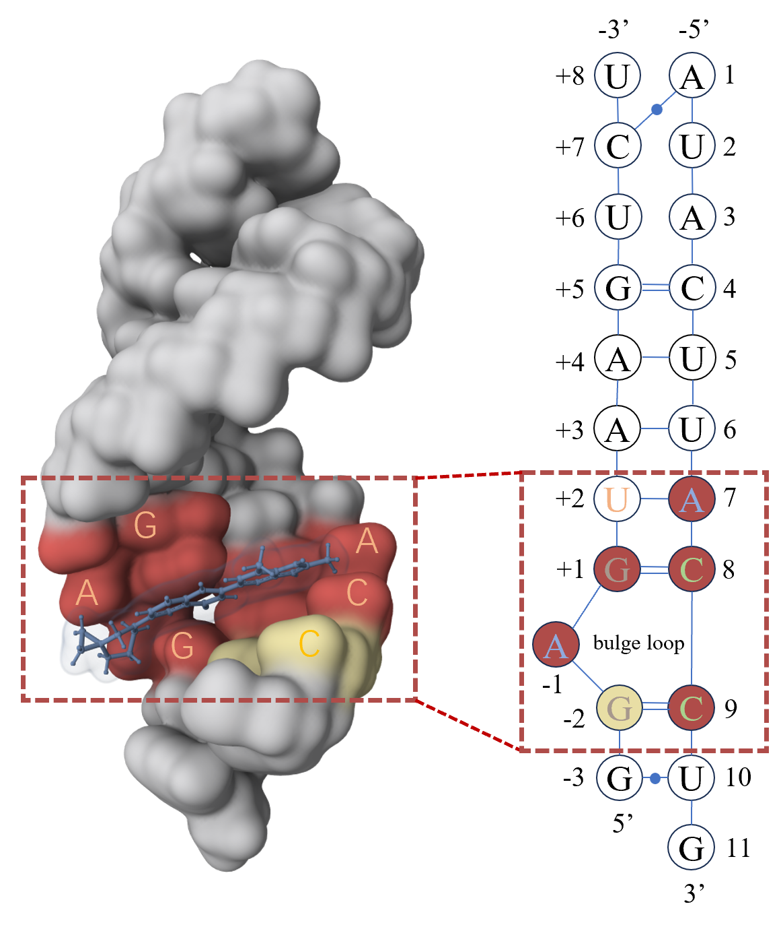

Fig. 1: Visualization of risdiplam’s binding, illustrating the predictive results of MVRBind in conjunction with the constructed secondary structure graph, where red denotes successfully predicted parts of the ligand-binding pocket, and yellow indicates regions where the prediction did not match the known pocket.

To address this, we have revised the description in the caption of Fig. 1 (which now corresponds to Fig. 5 in the main manuscript) to clarify that the red regions represent correctly predicted parts of the ligand-binding pocket, while yellow denotes regions where the prediction did not match the known pocket.

This change avoids confusion and ensures consistency with the standard usage of the term “binding site” in structural biology.

Comment 4: The Case study. Are there any RNAs in the training set that are similar to 8R62? Response 4: We thank the reviewer for this important and insightful comment. To address this issue thoroughly, we conducted detailed structural and sequence similarity analyses to confirm that 8R62 does not overlap with the training set.

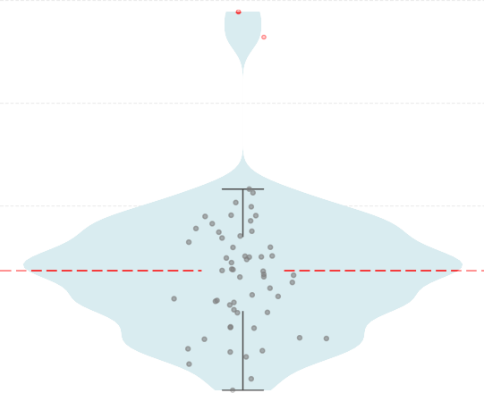0.5
Mean: 0.137
1YLS

2QUW

0.4

0.3
TM-score

0.2

0.1

0.0

Fig. 2: Distribution of TM-scores between structures from the Train60 dataset and the RNA 8R62.

First, we used RNA-align [5] to compute TM-scores [6] between 8R62 and each RNA in the training set. As shown in Fig. 2, two RNAs, namely, 1YLS and 2QUW, have TM-scores of 0.363 and 0.388 with 8R62, respectively. Based on established guidelines [7], TM-scores below 0.5 suggest that two structures do not share the same global fold. Therefore, 8R62 has no significant structural similarity with any RNAs in the training set.
Second, we clustered the RNAs in the training set plus 8R62 using MMseqs2 [8] in a two-step process. We first calculated all-versus-all pairwise alignments to evaluate the sequence identity between RNA sequences. Then, sequences were clustered using a greedy set-cover algorithm [9] with a sequence identity threshold of 0.3. Specifically, two sequences were grouped into the same cluster if they shared at least 30% sequence identity over the aligned region. As shown in Table 1, 8R62 formed a singleton cluster, indicating that its sequence similarity to any RNA in the training set is below this threshold.

TABLE 1: RNA clustering at 30% sequence identity. The red cluster (Cluster 48: 8R62) highlights a singleton RNA with no significant sequence similarity to the training set.

Cluster | Members | Cluster | Members | Cluster | Members
Cluster 1 | 3GX3 | Cluster 2 | 3MEI | Cluster 3 | 3OXE
Cluster 4 | 1EHT | Cluster 5 | 3Q3Z | Cluster 6 | 3Q50
Cluster 7 | 1FYP, 1BYJ | Cluster 8 | 3SKT | Cluster 9 | 1HR2
Cluster 10 | 3TZR | Cluster 11 | 1LVJ, 1AJU, 1ARJ, 1QD3, 1UTS, 1UUD, 2L8H | Cluster 12 | 3VRS
Cluster 13 | 1NBK | Cluster 14 | 4FRG | Cluster 15 | 1NTB
Cluster 16 | 4K31 | Cluster 17 | 4LVX | Cluster 18 | 1RAW
Cluster 19 | 4MEG | Cluster 20 | 1TOB | Cluster 21 | 4MGM
Cluster 22 | 4NYB | Cluster 23 | 4PCJ | Cluster 24 | 1Y90
Cluster 25 | 4QJH | Cluster 26 | 1YLS | Cluster 27 | 4QLM
Cluster 28 | 1YRJ | Cluster 29 | 4RGE | Cluster 30 | 4XW7
Cluster 31 | 2G5K | Cluster 32 | 5D5L | Cluster 33 | 2KGP, 1EI2
Cluster 34 | 5DH8 | Cluster 35 | 2KTZ | Cluster 36 | 5FJ1
Cluster 37 | 5J02 | Cluster 38 | 2LWK | Cluster 39 | 5O69
Cluster 40 | 2MXS | Cluster 41 | 5U3G | Cluster 42 | 2NOK
Cluster 43 | 5VCI | Cluster 44 | 6FZ0 | Cluster 45 | 2QUW
Cluster 46 | 6HAG | Cluster 47 | 2YIE | Cluster 48 | 8R62
Cluster 49 | 3BNQ | Cluster 50 | 3C44, 2FCY | Cluster 51 | 3FU2

Lastly, to further ensure robustness, we removed the two RNAs (1YLS and 2QUW) with the highest structural similarity to 8R62 and retrained the model. The evaluation results on 8R62 after retraining remained consistent, with the predicted ligand-binding and non-binding regions unchanged. These addi- tional analyses and updated model results have been incorporated into the revised manuscript. Relevant modifications and clarifications have been added to the Case Study section, and further details are provided in Supplementary Material Section 6.

Comment 5: Discussion and conclusion. “... and incorporating experimental data ...”. The method now relies on the experimental data (X-ray and NMR solved structures). Please be more specific, what types of data you are planning to incorporate.
Response 5: Thank you very much for your insightful comment. We apologize for not clearly specifying the types of experimental data we intend to incorporate in the original submission. To address this, we have now clarified that we plan to incorporate contextual experimental metadata and structural annotations in future work. These include crystallographic or spectroscopic conditions (e.g., temperature, pH, ion concentrations), functional descriptions of binding sites, mutation effects on binding affinity or RNA conformation, and detailed interaction features such as hydrogen bonding, base stacking, and electrostatic contacts. Although our current model primarily relies on RNA–ligand complex structures resolved by X-ray crystallography and NMR (as deposited in the PDB), we recognize that integrating this broader experimental context will enhance both model generalization and biological relevance.
Much of this valuable information is available in unstructured textual form within PDB entries and

associated literature. To utilize it effectively, we propose employing large language models (LLMs) to extract and encode these experimental insights alongside structural features. This multi-modal learning approach would enable our model to consider not only spatial and chemical characteristics but also the broader biochemical and structural context in which RNA–ligand interactions occur. We have revised the Discussion and Conclusion section to clarify these planned improvements.

Reviewer #2

Comment 1: While the use of graph convolutional networks (GCNs) and multi-view learning is well- motivated, the manuscript lacks a strong methodological novelty compared to prior works (e.g., RLBind, Rnet). Multi-view fusion and multi-scale aggregation via attention are now common in molecular model- ing, and the authors do not clearly demonstrate how MVRBind innovates beyond established frameworks.

Response 1: We thank the reviewer for the insightful comment. We agree that multi-view fusion and multi-scale aggregation are increasingly common in molecular modeling. However, accurate RNA–small molecule binding site prediction requires simultaneously considering multiple structural views, spatial scales, and their interactions. RNA’s flexibility leads to different conformations, altering the binding context. Therefore, features from one conformation often fail to generalize to others or the apo state, complicating prediction. Primary, secondary, and tertiary structures, along with local to global scales, are coupled and jointly shape binding. Structural changes within one scale can affect views differently, and changes in one view can propagate unevenly across scales, reflecting the complex coupling in RNA’s hierarchical organization.
While some existing methods consider multi-scale modeling, they often focus only on the sequence level, neglecting other structural views and the interactions between views and scales. For example, RLBind captures multi-scale patterns in sequences but ignores other structural views, while Rnet uses structural input without modeling interactions between structural views and scales. These limitations reduce their generalization to diverse RNA conformations and their robustness to noisy structural data.
To address these challenges, we developed MVRBind, a GCN-based model that integrates multiple structural views and spatial scales, along with their interactions, in a unified strategy for RNA–ligand binding site prediction. MVRBind employs separate GCN encoders to process RNA’s primary, secondary, and tertiary structures as distinct views, enabling the extraction of specialized features tailored to each structural level. A multi-scale module captures both local and global contextual patterns within each view, reflecting different levels of binding context. These representations are then integrated via two complementary attention mechanisms. One adaptively weights the reliability of each view within the same scale. The other models dependencies across scales, allowing the model to capture structural hierarchies and context-sensitive interactions. This design allows MVRBind to fully exploit the complementary and coupled nature of RNA’s structural information. It emphasizes more reliable views when others are uncer- tain and dynamically integrates cross-scale signals. As a result, MVRBind achieves better generalization across diverse RNA conformations, especially in the challenging apo state. It offers improved robustness

to RNA structural flexibility, a core challenge in RNA–ligand binding site prediction.
We have revised the Introduction section accordingly to clarify these points and thank the reviewer again for encouraging us to better articulate the contributions and motivations of our work.

Comment 2: The datasets used (e.g., Train60 with 60 RNAs, Test18 with 18 RNAs) are relatively small, raising concerns about overfitting and generalizability of the model. The Conformational test set is constructed from only three RNAs with multiple conformations.
Response 2: We sincerely thank the reviewer for raising the important issue of dataset size and the potential risk of overfitting and limited generalizability. We would like to address these concerns by (i) clarifying how the datasets were constructed and processed, (ii) describing the strategies we employed to mitigate overfitting, and (iii) presenting additional evaluation results on a larger dataset to further demonstrate the generalizability of our model.

Rigorous dataset construction
While relatively small in size, the Train60 and Test18 datasets [10] were constructed with rigorous cri- teria to ensure that models trained and evaluated on them can achieve reliable generalization performance. Specifically, the Train60 and Test18 datasets [10] contain 60 and 18 RNA chains respectively, and were derived through a highly stringent filtering and de-redundancy pipeline. Starting from 1673 RNA chains, Su et al. applied size and quality filters, then removed chains lacking small molecule interactions. To further reduce redundancy, they employed both structural similarity filtering using TM-score computed via RNA-align [5] and sequence-based clustering with a 30% identity threshold. This ensures each RNA represents a unique structural and sequence class, minimizing potential data leakage between the training and test sets. As a result, models that perform well on this dataset are likely to generalize effectively across diverse and previously unseen RNA structures.
Regarding the Conformational Test set, although it includes only three distinct RNAs, it comprises 47 experimentally resolved conformations spanning a total of 1,160 nucleotides, with 21, 20, and 6 confor- mations corresponding to each RNA, respectively. Since each nucleotide is treated as an input sample in our study, the dataset still provides a substantial amount of data for evaluating model performance and robustness.

Efforts to prevent overfitting
To mitigate overfitting risks, we incorporated multiple regularization techniques in the training pipeline, including L2 weight regularization, Batch Normalization (BN), Dropout layers, and data augmentation through dynamic perturbation of RNA structures to increase input variability. The specific settings of

these regularization strategies are detailed in Table 2.

TABLE 2: Regularization strategies and hyperparameter settings used in the training pipeline.

Regularization Technique Parameter / Strategy Value / Description

L2 Regularization Weight decay 1 10⁻²
×
Batch Normalization BN layer Applied after linear layer (128-dim) Dropout Dropout rate 0.5 (used after most major layers) Data Augmentation Gaussian perturbation ±0.05 (applied to input features)

We also monitored training and validation loss curves during model optimization. As illustrated in Fig. 3, both losses steadily decreased and converged after approximately 60 epochs. This stable convergence shows that the model does not suffer from overfitting and is thus able to learn generalizable features from the data.

0.75
Train Loss
Validation Loss

0.70

0.65
Loss

0.60

0.55

0 20 40 60 80 100 120 140
Epoch

Fig. 3: Training and validation loss curves over epochs.

Evaluation on a larger benchmark dataset
To further demonstrate the generalizability of our model, we conducted additional experiments on HARIBOSS dataset [11] which contains 353 RNA chains with 35114 nucleotides. In particular, following RNABind [12], the HARIBOSS dataset was preprocessed by removing RNA structures with more than 500 nucleotides and those containing modified nucleotides to ensure consistency in structural quality. The resulting dataset was clustered into 129 groups using TM-score–based structural similarity with a threshold of 0.5, following the strategy proposed in RNABind [12]. Then, four structure-based splits (i.e.,

Set1, Set2, Set3 and Set4 as shown in Table 3) were created as non-overlapping training, validation, and test sets based on these clusters [12]. Note that this splitting strategy ensures that structurally similar RNAs do not appear across different sets, thereby providing a rigorous evaluation of model generalization. The detailed dataset composition is provided in Table 3.
TABLE 3: The details of four structure split datasets. The number of binding sites (positive samples) and non-binding sites (negative samples) are shown in parentheses.

Set
Train Validation Test

RNA chains (Pos : Neg) RNA chains (Pos : Neg) RNA chains (Pos : Neg)

Set1 | 262 | (3583:22330) | 46 | (565:4406) | 45 | (810:3420)
Set2 | 284 | (4174:23132) | 31 | (350:2274) | 38 | (434:4750)
Set3 | 261 | (3809:18735) | 41 | (376:4261) | 51 | (773:7160)
Set4 | 277 | (3695:21902) | 39 | (675:1387) | 37 | (588:6867)

As shown in Fig. 4, MVRBind consistently outperforms RNABind, RLBind and Rnet in terms of AUC across all four splits. These three baselines were selected for the following reasons. First, RNABind is the most recent method for RNA–ligand binding site prediction, published in 2025. Second, RLBind and Rnet demonstrated strong performance in our prior evaluation on the Test18 dataset. Overall, MVRBind’s consistent advantage on this large and diverse benchmark helps to address concerns regarding potential overfitting and limited generalizability raised in the context of the smaller primary dataset.

0.85
RLBind
rs
Ou
ABind
RN
Rnet

0.80

0.75

0.70
AUC

0.65

0.60

0.55

0.50

Set1

Set2

Set3

Set4

Fig. 4: AUC scores of RNABind, RLBind, Rnet, and our method evaluated on four splits of the HARIBOSS dataset.

We acknowledge that limited availability of experimentally determined RNA-ligand complex structures

poses a common challenge for the community. To overcome this, we plan to expand the dataset as more structures become available and explore advanced strategies such as pretraining on related RNA structure datasets and transfer learning to enhance generalization capabilities. We have clarified these points and included the relevant details in the Results section. We hope this comprehensive explanation addresses the reviewer’s concerns regarding dataset size and overfitting.

Comment 3: The baseline methods lack modern deep learning comparisons beyond RLBind. For example, methods leveraging protein-RNA interactions, equivariant networks (e.g., SE(3)-Transformer), or RNA foundation models are not included.
Response 3: Thank you for this valuable suggestion. We appreciate the reviewer’s insight and have addressed this comment in the following three aspects.
First, while protein–RNA interaction methods are important, we would like to clarify that our task is inherently different. Protein–RNA interaction prediction is typically a binary or regression-level task that treats the protein and RNA as global entities, predicting whether they bind or what the binding affinity is. In contrast, our task focuses on identifying fine-grained binding sites on the RNA for small molecules, which involves residue-level labeling. Furthermore, proteins are generally larger and struc- turally more complex than RNAs, making methods designed for protein–RNA interaction less transferable to RNA–small molecule binding site prediction without substantial modification. Therefore, we did not include protein-RNA interaction methods in our evaluation.
Second, to assess whether recent advances in equivariant neural networks can enhance RNA–ligand binding site prediction, we included RNABind [12] as a baseline for comparison. RNABind integrates RNA foundation model embeddings with an Equivariant Graph Neural Network (EGNN) [13] to capture the geometric properties of RNA structures. For fairness, we trained and evaluated RNABind using the same datasets and experimental protocols as our proposed method. As shown in Table 4, our MVRBind significantly outperforms RNABind in terms of MCC and AUC. The comparison results in terms of other metrics such as Precision and Recall can be found in Table S6 in our supplementary materials.
TABLE 4: Performance comparison of RNABERT, RNAErnie, RNA-FM, RNABind, and our method across multiple datasets.

Models | Test 18 |  | Apo Test |  |  | Conformational Test |  |  | Set1 |  | Set2 |  |  | Set3 |  |  | Set4
 | MCC | AUC |  | MCC | AUC |  | MCC | AUC |  | MCC | AUC |  | MCC | AUC |  | MCC | AUC |  | MCC | AUC
RNABind | 0.263 | 0.717 |  | 0.144 | 0.657 |  | 0.018 | 0.532 |  | 0.232 | 0.757 |  | 0.055 | 0.707 |  | 0.032 | 0.688 |  | 0.144 | 0.685
RNABERT+MLP | 0.243 | 0.682 |  | 0.070 | 0.696 |  | 0.142 | 0.599 |  | 0.184 | 0.701 |  | 0.091 | 0.680 |  | 0.047 | 0.528 |  | 0.116 | 0.611
RNAErnie+MLP | 0.066 | 0.569 |  | 0.102 | 0.544 |  | 0.126 | 0.614 |  | 0.142 | 0.621 |  | 0.198 | 0.687 |  | 0.015 | 0.573 |  | 0.080 | 0.597
RNA-FM+MLP | 0.105 | 0.591 |  | 0.061 | 0.586 |  | 0.015 | 0.593 |  | 0.207 | 0.745 |  | 0.108 | 0.701 |  | 0.026 | 0.606 |  | 0.056 | 0.576
Ours | 0.351 | 0.745 |  | 0.228 | 0.756 |  | 0.181 | 0.660 |  | 0.306 | 0.785 |  | 0.207 | 0.740 |  | 0.188 | 0.697 |  | 0.220 | 0.693

Third, we agree that RNA foundation models offer valuable prior knowledge for downstream tasks. Following the reviewer’s suggestion, we explored three representative RNA foundation models, namely, RNABERT [14], RNAErnie [15], and RNA-FM [16] for the RNA–ligand binding site prediction task. Specifically, we adopted a fine-tuning strategy where pretrained nucleotide embeddings were fed into a multilayer perceptron (MLP) classifier, and the MLP was fine-tuned for binding site prediction. As shown in Table 4, our proposed MVRBind model consistently outperforms all the three foundation models, which were pretrained from RNA sequences only. These results highlight the importance of explicitly modeling RNA structural information for accurate RNA–ligand binding site prediction.
Once again, we thank the reviewer for raising these valuable points. We have revised the manuscript accordingly in the Introduction, Materials, and Results sections to incorporate the additional baselines and evaluation results, clarify our methodology, and enhance the overall discussion.

Comment 4: The labels for apo structures are transferred from holo structures assuming conserved binding residues. This strong assumption may introduce label noise, especially given RNA flexibility.
Response 4: Thank you for this insightful comment. We acknowledge that transferring binding site labels from holo to apo structures involves the assumption that binding residues are conserved across conformations. This assumption may not always hold due to the inherent flexibility of RNA molecules. However, this is a commonly adopted approximation in RNA–ligand binding site prediction, especially in the absence of experimentally annotated binding residues in apo structures. Our labeling strategy follows previous work such as SHAMAN [17] and RNASite [10], which also annotate apo conformations using holo-derived binding information.
To further mitigate the impact of potential label noise introduced by RNA flexibility, our model is designed to explicitly integrate multi-level RNA structural information, including sequence, secondary structure, and 3D geometry, during both graph construction and feature extraction. The primary and secondary structure graphs encode topological and base-pairing patterns that tend to remain stable across apo and holo states, providing robust features that are less sensitive to conformational variability. Mean- while, the tertiary-level geometric features capture fine-grained spatial cues that are critical for accurate binding site localization. This hierarchical structural representation enables our model to remain robust in the presence of moderate structural variation, effectively reducing the impact of imperfect binding site annotations in apo structures. We believe this architectural design is a key reason why our method performs reliably under realistic settings, despite the absence of experimentally labeled binding residues in apo RNA structures. We have clarified this point and made corresponding revisions in the Materials section of the manuscript.

Comment 5: The model’s recall remains low (e.g., 0.342 on Test18, 0.296 on Conformational test), indicating that many true binding sites are missed. This undermines its use in drug discovery, where false negatives are costly.

Response 5:
Thank you for your insightful comments regarding the recall performance of our model. We recognize that recall is relatively low on certain benchmarks, which may result in missed true binding sites. We fully agree with the reviewer that false negatives (i.e., missing true binding sites) are costly, as we may miss some promising targets.
In our experiments, we slightly favor precision to prioritize high-confident predictions and minimize false positives. However, we acknowledge that both precision and recall are sensitive to the chosen prediction threshold in binary classification. Specifically, in our binary classification task, the model outputs a continuous probability score between 0 and 1, and we classify instances as positive if the score exceeds a predefined threshold. By lowering this threshold, we label more instances as positive, thereby increasing recall (i.e., detecting more true positives), but this also increases the risk of including more false positives, thus reducing precision. Conversely, raising the threshold can yield higher precision but at the cost of lower recall.
To mitigate the dependency on a fixed threshold and provide a more holistic view of model performance, we reported threshold-independent metrics such as the ROC-AUC score. ROC-AUC evaluates the model’s ability to rank positive instances higher than negative ones across all possible thresholds. It reflects the trade-off between the true positive rate (recall) and the false positive rate, without requiring commitment to a single decision threshold. As such, it allows for a fair comparison of models based on their intrinsic discriminative power, rather than on a specific classification decision rule.
In future work, we plan to implement a flexible threshold selection mechanism based on a preci- sion–recall weighted Fβ score [18], allowing users to tailor the trade-off between precision and recall according to their application needs, whether emphasizing hit discovery (higher recall) or minimizing false leads (higher precision).

Comment 6: Deep learning is well-known and has been used in previous bioinformatics studies i.e., PMID: 38177735, PMID: 36385847. Therefore, the authors are suggested to refer to more works in this description to attract a broader readership.
Response 6: Thank you for the constructive suggestion. We agree that deep learning has been widely applied in bioinformatics, as demonstrated by previous studies (PMID: 38177735 [19], PMID: 36385847

[20]). In response, we have revised the Introduction section to include these references, thereby providing a more comprehensive overview of relevant literature.

Comment 7: Several key implementation details and results (e.g., full model architecture diagrams, GCN layer sensitivity, full list of PDB IDs) are buried in the Supplementary Material, which hinders readability. Response 7: Thank you for pointing this out. We agree that details such as the model architecture diagram, the GCN layer sensitivity analysis, and the full list of PDB IDs are important to fully understand our work. In response, we have moved the full model architecture diagram and a summary of the GCN layer sensitivity analysis from the Supplementary Material into the main manuscript to improve readability. The complete list of PDB IDs remains in the Supplement due to space limitations, but we have added a clearer reference to it in the main text. We appreciate the reviewer’s suggestion and believe these revisions significantly improve the clarity and accessibility of the paper.

Comment 8: The abstract and conclusion imply the model is generalizable across RNA conformations and for drug discovery, yet no prospective or real-case validation (e.g., docking score correlation or pharmacophore enrichment) is conducted.
Response 8: We thank the reviewer for this insightful comment. As correctly pointed out, our cur- rent study focuses on predicting RNA binding sites from structural features, and we did not perform prospective validation in real-world drug discovery scenarios, such as correlation with docking scores or pharmacophore-based enrichment. While the performance on the Conformational test set suggests that our model is robust across different RNA conformations, we acknowledge that this alone does not constitute validation for downstream applications like virtual screening.
Our primary goal was to demonstrate that the model can learn structural and geometric patterns indicative of ligand-binding potential, which we consider an essential foundation for subsequent drug discovery tasks. That said, we fully agree that stronger claims regarding practical utility in drug discovery should be supported by further experimental or prospective computational validation.
In response to the reviewer’s concern, we have revised both the Abstract and the Discussion and Conclusion sections to more clearly define the current scope of our study, which centers on the prediction and analysis of RNA–small molecule binding sites using a structure-based deep learning framework. We have also highlighted potential future directions, such as RNA–ligand docking and fragment-based screening, which are being actively explored in our ongoing and planned follow-up work. Specifically, we updated the Abstract to include the sentence: “ These results suggest that MVRBind offers a robust model for structure-based RNA analysis, contributing toward accurate prediction and analysis of RNA–small

molecule binding sites.” In the Discussion and Conclusion section, we added: “ In conclusion, MVRBind offers a robust approach for structure-based analysis of RNA–ligand binding sites. Its ability to generalize across diverse RNA conformations provides a solid foundation for accurate prediction and comprehensive characterization of RNA–small molecule binding sites. Building on this foundation, we are actively pursuing future directions such as docking and fragment-based screening in ongoing and planned follow- up studies, which will further advance RNA-targeted molecular research.” These revisions clarify the scope of our work and highlight future directions like docking and fragment-based screening, which we are actively pursuing.

Comment 9: The manuscript omits details on computational efficiency, including training time, GPU resources, or inference speed. This is particularly important if the method is to be adopted in drug pipelines.
Response 9: We fully agree that computational efficiency is crucial for practical adoption, particularly in drug discovery pipelines where scalability and runtime are key considerations. To address this, we provide key efficiency-related metrics of our method in Table 5. In addition, our model contains 1.47 million trainable parameters and has a total size of only 6.0 MB. All experiments were conducted on a single NVIDIA RTX 4070 GPU (8GB). These details have been added to the revised manuscript, specifically in the Methods section, to enhance transparency, reproducibility, and practical relevance.
TABLE 5: Summary of model training and inference efficiency

Time | Train60 | HARIBOSS
Total training time | 36 seconds | 204 seconds
Total inference time | 0.18 seconds (Test18) | 0.59 seconds (Set1)
Inference time per residue | 3.0 × 10⁻⁴ seconds | 1.3 × 10⁻⁴ seconds

Reviewer #3

Summary: This is a well-written and carefully constructed paper. The authors present MVRBind, a framework that elegantly combines different structural perspectives of RNA to improve prediction of ligand binding sites. The novelty lies in the structured integration of graph-based encodings for each level of RNA structure, fused through attention mechanisms and GCNs. The model shows competitive results and robustness, particularly in scenarios where traditional models struggle (e.g., conformational variability, apo structures). The evaluation is rigorous, and the code/data availability is commendable. I recommend Major Revision. Upon addressing the points above, this manuscript will be well-suited for publication in Briefings in Bioinformatics.
Response: Thank you for your thoughtful and constructive review. We sincerely appreciate your sugges- tions and have carefully revised the manuscript to address all the comments.

Comment 1: While MVRBind performs well across the defined test sets, it is not clear how it might generalize to RNAs from unrelated families or species. Since the goal is applicability in drug discovery pipelines, real-world validation scenarios should be acknowledged. Please include a short discussion in the “Discussion and Conclusion” section about: The limitations of the current dataset (e.g., are certain RNA classes underrepresented?); How the model might behave when applied to RNAs with no structural homologs in training; and Whether fine-tuning or domain adaptation would be possible.
Response 1: Thank you for these valuable comments. We address the points as follows:
- Limitations of the current dataset: Our dataset includes diverse RNA types covering a broad range of sequences and tertiary structures. For example, it contains common classes such as tRNAs, riboswitches, and viral RNAs including the HIV TAR RNA element. However, some RNA classes remain underrepresented due to limited availability of high-resolution structures in public databases. Long non-coding RNAs (lncRNAs), in particular, are less represented compared to other classes. This imbalance may lead to biased performance favoring well-represented RNA families and associated structural motifs. This distribution reflects current data availability and underscores the need for ongoing expansion of RNA structural datasets to improve model robustness and coverage.
- Generalization to RNAs with no structural homologs: We performed stringent redundancy removal at both sequence and structural levels between training and test sets to minimize overlap and encourage generalization. However, the model has not yet been systematically evaluated on RNAs with entirely novel folds absent from the training data. While the multi-level encoding of sequence, secondary structure, and 3D geometry suggests potential for generalization, this remains to be

validated thoroughly. A comprehensive assessment on novel RNA folds is an important direction for future work.
- Fine-tuning and domain adaptation: The modular architecture of our model enables efficient fine-tuning on new RNA classes, particularly when annotated data is limited. Additionally, domain adaptation techniques—including transfer learning, self-training, and contrastive pretraining—offer promising ways to improve performance on underrepresented RNA families. This adaptability is especially valuable in drug discovery applications, where novel RNA targets with diverse features frequently arise.
We have incorporated these points into the revised “Discussion and Conclusion” section to transparently acknowledge the dataset limitations, anticipated model behavior on novel RNAs, and potential for future adaptation and extension.

Comment 2: The performance on apo and conformational datasets is a key strength of this paper. However, deeper insights into the nature of false predictions would be useful, especially given the structural flexibility of apo RNA. Consider including a brief error analysis, possibly in the Supplementary Materials, that highlights: Common characteristics of false positives and false negatives on apo test sets and whether errors are associated with certain secondary structure elements (e.g., bulges, pseudoknots).
Response 2: Thank you for the insightful suggestion. As part of our response, we conducted a localized error analysis on representative apo RNA samples, with results summarized in Fig. 5.
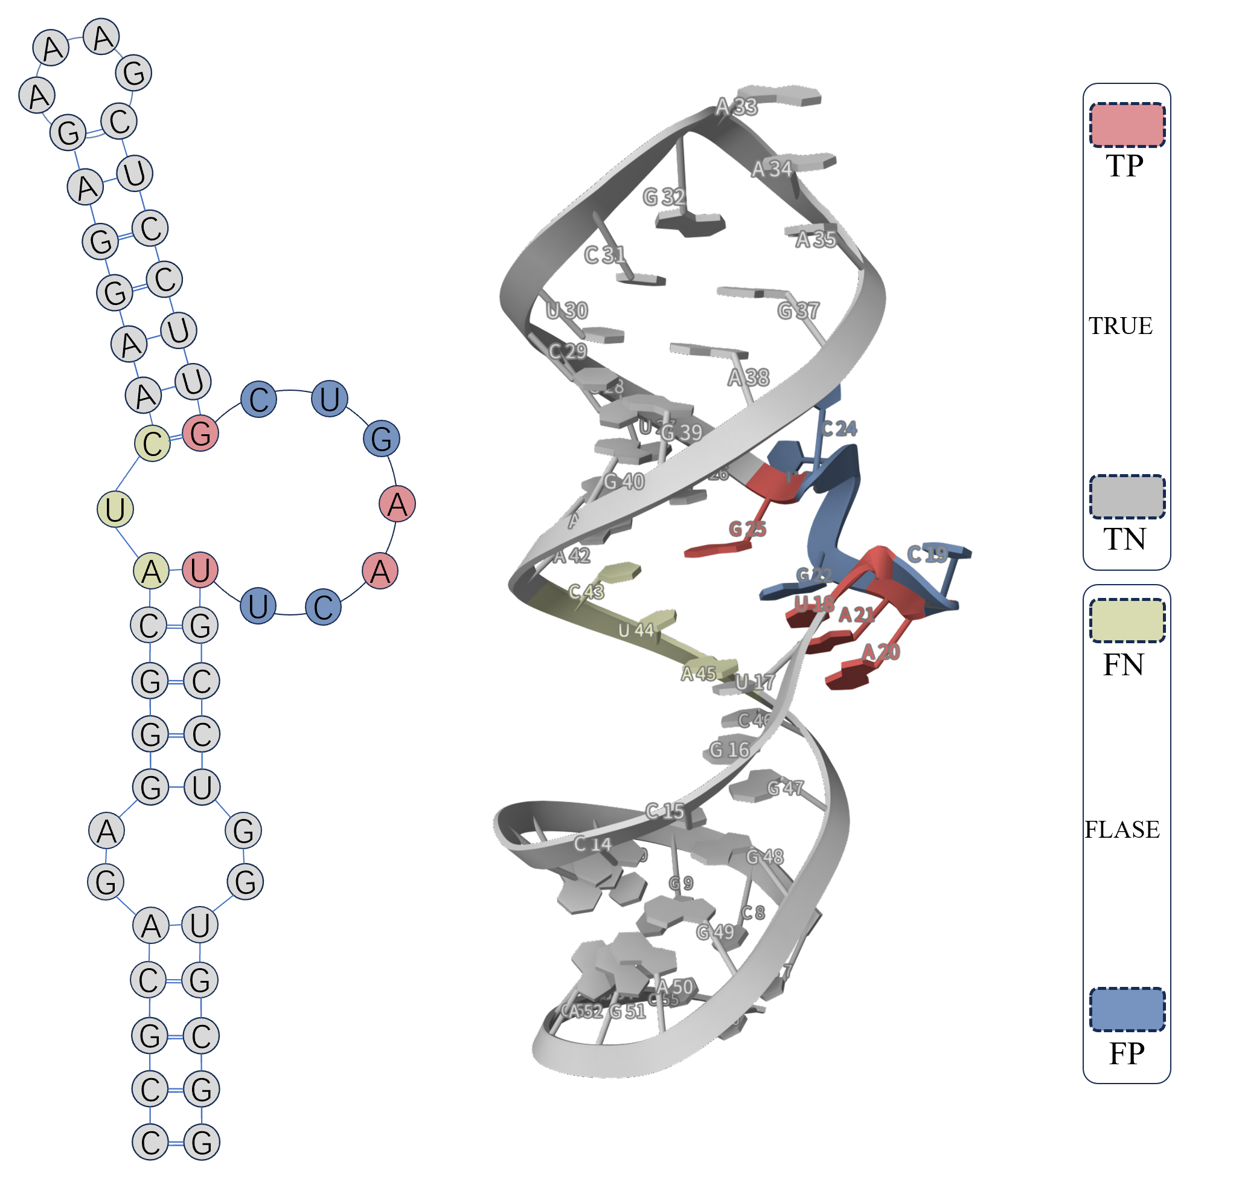
Fig. 5: Error analysis on representative apo RNA structures. False negatives (yellow) and false positives (blue) frequently occur in flexible internal loops. True positives are shown in red, and true negatives are shown in gray.

We observed that a large proportion of false negatives (yellow nodes) and false positives (blue nodes)

occur in internal loops, which are typically flexible and solvent-accessible. Compared to other secondary structure elements, internal loops often form larger cavities relative to the size of the ligand and can undergo more complex tertiary folding. This makes it challenging for the model to precisely localize the binding site within these regions. While the model correctly identifies the broader internal loop as a potential binding region, it may misestimate the exact orientation or entry point of the ligand, leading to minor spatial shifts in predicted binding residues. Despite these challenges, we find that the model still performs well in identifying the overall binding pocket or cavity, even when residue-level precision is imperfect.
We have added this discussion and representative visualizations to the Supplementary Materials Section 7, and briefly summarized the findings in the Result section.

Comment 3: The section on structure prediction using RNAComposer and AlphaFold3 is informative but lacks methodological detail about how these structures are integrated into the pipeline and how errors propagate. Expand this discussion to address: How MVRBind handles predicted tertiary structures with high RMSD; whether it is advisable to use MVRBind with predicted models when tertiary structures are not experimentally known and how sensitive MVRBind is to inaccuracies in secondary structure prediction tools (e.g., RNApdbee).
Response 3: We thank the reviewer for these insightful comments. In response, we have expanded the relevant discussions in the manuscript (Discussion section) and added supporting analyses to the Supplementary Materials. Please find our detailed replies below:
- How MVRBind handles predicted tertiary structures with high RMSD: MVRBind integrates hierarchical structural representations—including RNA sequence, predicted secondary structure, and 3D geometry—making it moderately robust to imperfections in tertiary structure predictions. When predicted 3D models have a high RMSD but preserve the global fold and canonical base-pairing, MVRBind retains competitive performance. However, in cases of severe distortion—such as col- lapsed helices or misoriented domains—model performance, especially precision, declines. Notably, AlphaFold3 provides per-residue confidence scores (pLDDT), which can help assess the local re- liability of predictions. We recommend using these scores to screen out low-confidence predicted structures prior to applying MVRBind.
- Whether it is advisable to use MVRBind with predicted models when tertiary structures are not experimentally known: MVRBind can be applied to predicted RNA structures (e.g., from RNAComposer or AlphaFold3) when experimentally resolved structures are unavailable. Based on the results presented in Supplementary Section 4, MVRBind performs reliably on structures with

reasonable fold quality and canonical secondary motifs. However, since MVRBind is not trained to correct structurally unrealistic inputs, we recommend basic quality checks on predicted models, including structural plausibility and AlphaFold3 confidence filtering. These considerations have been clarified in the revised Discussion.
- How sensitive MVRBind is to inaccuracies in secondary structure prediction tools (e.g., RNApdbee): To evaluate this, we conducted controlled experiments where we added different levels of noise to the predicted secondary structure of RNAs in the test set. Specifically, we randomly altered secondary structure edges (base-pairings) and node features at varying noise ratios. We found that the model’s average AUC remains relatively stable when the noise ratio is below 10%, indicating good robustness to moderate inaccuracies in predicted secondary structures, as shown Fig. 6. This robustness stems from MVRBind’s multi-modal design, where sequence and 3D geometry features help compensate for local secondary structure errors. Performance degradation becomes more evident beyond this noise threshold.

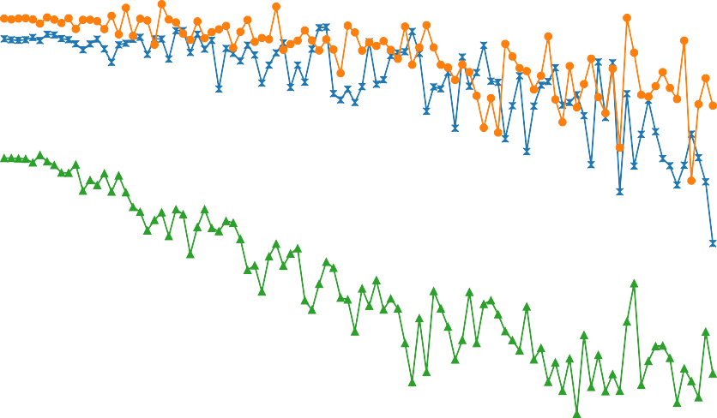0.75
Test18
Apo Test
Conformational Test

0.70

0.65
ROC AUC

0.60

0.55

0.0 0.1 0.2 0.3 0.4 0.5 0.6
Noise Level

Fig. 6: Robustness of MVRBind to noise in secondary structure inputs. Line plot showing the average AUC of MVRBind on the test set under varying levels of noise added to the secondary structure graph.

We have included this analysis and the corresponding figure in the Supplementary Materials Section 8.

Comment 4: Line 116: Correct “the the holo form” → “the holo form”.
Response 4: We thank the reviewer for catching this typographical error. We have corrected “the the holo form” to “the holo form” in the revised manuscript.

Comment 5: Table captions: Please define all abbreviations (e.g., TP, FP, AUC, MCC) at first occurrence in each table/figure caption, for clarity.
Response 5: We appreciate this helpful suggestion. We have revised all relevant table and figure captions to define abbreviations such as TP (True Positive), FP (False Positive), AUC (Area Under the Curve), and MCC (Matthews Correlation Coefficient) at their first occurrence for improved clarity. We have added a detailed description of the metrics used to evaluate RNA–small molecule binding site prediction models. Specifically, true positives (TP) are nucleotides correctly predicted as binding sites, false positives (FP) are non-binding nucleotides incorrectly predicted as binding sites, true negatives (TN) are non-binding nucleotides correctly predicted as non-binding, and false negatives (FN) are binding sites incorrectly predicted as non-binding. Precision measures the proportion of predicted binding sites that are correct,
defined as

$$\begin{aligned}precision= \frac{TP}{T P + F P }.\#\left(1\right)\end{aligned}$$

Recall quantifies the proportion of actual binding sites correctly identified
$$\begin{aligned}recall= \frac{TP}{T P + F N }.\#\left(2\right)\end{aligned}$$

The Matthews Correlation Coefficient (MCC), particularly suitable for imbalanced datasets, provides a balanced assessment of classification performance and is calculated as
$$\begin{aligned}MCC= \frac{ T P · T N - F P · F N}{\sqrt{\left(TP + FP \right)\left(TP + FN \right)\left(TN + FP \right)\left(TN + FN \right)}}.\#\left(3\right)\end{aligned}$$
Finally, the Area Under the ROC Curve (AUC) measures the model’s ability to discriminate binding versus non-binding nucleotides across all thresholds, with higher AUC indicating better overall perfor- mance. Together, these metrics comprehensively evaluate the accuracy, robustness, and generalizability of our prediction models. These descriptions have been incorporated into the Results section of the revised manuscript.

Comment 6: Figures 2 and 3: Consider adding nucleotide numbering, color legends, and secondary structure annotations to help non-experts interpret the prediction accuracy.
Response 6: Thank you for this valuable suggestion. We have updated Figures 2 and 3 to include nucleotide numbering, a detailed color legend, and annotated secondary structure elements. These en- hancements aim to make the figures more accessible to non-expert readers and improve interpretability. The revised Figures 2 and 3, along with updated figure captions, are included in the main manuscript.

Comment 7: Citation formatting: Ensure all citations follow a consistent style (some lack publication years or are abbreviated inconsistently).
Response 7: We appreciate the reviewer’s attention to detail. We have reviewed and revised all references to ensure consistent formatting in terms of citation style, inclusion of publication years, and standardized abbreviation of author names and journal titles. The corrections have been made throughout the main text and in the References section.

Comment 8: Typos and grammar: A final grammar and style check is recommended to address occasional repetition and punctuation inconsistencies.
Response 8: Thank you for pointing this out. We have carefully proofread the manuscript and corrected instances of typographical repetition, punctuation errors, and grammatical inconsistencies to improve readability and polish. These revisions have been made throughout the manuscript.

Comment 9: Table 2: The comparative performance table is useful, but it would help to briefly mention in the captions why Rsite is not applicable to the conformational test.
Response 9: We thank the reviewer for this observation. We have revised the caption of Table 2 to clarify that Rsite predicts binding sites based on sequence-derived structural predictions; however, since the sequence remains identical in the conformational test, Rsite is not suitable for evaluation on this task. This clarification has been added to the caption of Table 2 (which now corresponds to Table 4 in the main manuscript).

Comment 10: Supplementary Figures: Please ensure each supplementary table/figure referenced in the main text is labeled precisely and clearly (e.g., “see Supplementary Figure S1” instead of “see figure in Supplement”).
Response 10: We appreciate this clarification request. We have reviewed all references to supplementary material in the main text and updated them to include precise labels, ensuring consistency and clarity throughout the manuscript. These updates have been made throughout the main text where supplementary materials are referenced.

REFERENCES
- Vincent Le Guilloux, Peter Schmidtke, and Pierre Tuffery. Fpocket: an open source platform for ligand pocket detection. BMC bioinformatics, 10(1):168, 2009.
- Seth D Veenbaas, Simon Felder, and Kevin M Weeks. fpocketr: A platform for identification and analysis of ligand-binding pockets in rna. bioRxiv, pages 2025–03, 2025.
- Seth D Veenbaas, Jordan T Koehn, Patrick S Irving, Nicole N Lama, and Kevin M Weeks. Ligand- binding pockets in rna and where to find them. Proceedings of the National Academy of Sciences, 122(17):e2422346122, 2025.
- Ilaria Manfredonia, Chandran Nithin, Almudena Ponce-Salvatierra, Pritha Ghosh, Tomasz K Wirecki, Tycho Marinus, Natacha S Ogando, Eric J Snijder, Martijn J van Hemert, Janusz M Bujnicki, et al. Genome-wide mapping of sars-cov-2 rna structures identifies therapeutically-relevant elements. Nucleic acids research, 48(22):12436–12452, 2020.
- Sha Gong, Chengxin Zhang, and Yang Zhang. Rna-align: quick and accurate alignment of rna 3d structures based on size-independent tm-scorerna. Bioinformatics, 35(21):4459–4461, 2019.
- Yang Zhang and Jeffrey Skolnick. Scoring function for automated assessment of protein structure template quality. Proteins: Structure, Function, and Bioinformatics, 57(4):702–710, 2004.
- Jinrui Xu and Yang Zhang. How significant is a protein structure similarity with tm-score= 0.5?
Bioinformatics, 26(7):889–895, 2010.
- Martin Steinegger and Johannes So¨ding. Mmseqs2 enables sensitive protein sequence searching for the analysis of massive data sets. Nature biotechnology, 35(11):1026–1028, 2017.
- Neal E Young. Greedy set-cover algorithms. In Encyclopedia of algorithms, pages 886–889. Springer, 2016.
- Hong Su, Zhenling Peng, and Jianyi Yang. Recognition of small molecule–rna binding sites using rna sequence and structure. Bioinformatics, 37(1):36–42, 2021.
- Francesco P Panei, Rachel Torchet, Herve Menager, Paraskevi Gkeka, and Massimiliano Bonomi. Hariboss: a curated database of rna-small molecules structures to aid rational drug design. Bioinformatics, 38(17):4185–4193, 2022.
- Weimin Zhu, Xiaohan Ding, Hong-Bin Shen, and Xiaoyong Pan. Identifying rna-small molecule binding sites using geometric deep learning with language models. Journal of Molecular Biology, page 169010, 2025.
- Vıctor Garcia Satorras, Emiel Hoogeboom, and Max Welling. E (n) equivariant graph neural networks. In International conference on machine learning, pages 9323–9332. PMLR, 2021.

- Manato Akiyama and Yasubumi Sakakibara. Informative rna-base embedding for functional rna structural alignment and clustering by deep representation learning. bioRxiv, pages 2021–08, 2021.
- Ning Wang, Jiang Bian, Yuchen Li, Xuhong Li, Shahid Mumtaz, Linghe Kong, and Haoyi Xiong. Multi-purpose rna language modelling with motif-aware pretraining and type-guided fine-tuning. Nature Machine Intelligence, 6(5):548–557, 2024.
- Jiayang Chen, Zhihang Hu, Siqi Sun, Qingxiong Tan, Yixuan Wang, Qinze Yu, Licheng Zong, Liang Hong, Jin Xiao, Tao Shen, et al. Interpretable rna foundation model from unannotated data for highly accurate rna structure and function predictions. arXiv preprint arXiv:2204.00300, 2022.
- FP Panei, P Gkeka, and M Bonomi. Identifying small-molecules binding sites in rna conformational ensembles with shaman. Nature Communications, 15(1):5725, 2024.
- Zachary C Lipton, Charles Elkan, and Balakrishnan Naryanaswamy. Optimal thresholding of classifiers to maximize f1 measure. In Joint European Conference on Machine Learning and Knowledge Discovery in Databases, pages 225–239. Springer, 2014.
- Nguyen Quoc Khanh Le. Predicting emerging drug interactions using gnns. Nature Computational Science, 3(12):1007–1008, 2023.
- Zhengyun Zhao, Jingyu Gui, Anqi Yao, Nguyen Quoc Khanh Le, and Matthew Chin Heng Chua. Improved prediction model of protein and peptide toxicity by integrating channel attention into a convolutional neural network and gated recurrent units. ACS omega, 7(44):40569–40577, 2022.

